**Programming Assignment #1**

It is common knowledge that digital images currently are a vital part of most people’s lives, they capture moments in a way that just was not possible not so long ago. However, sometimes these images get taken under not ideal conditions, low-lighting scenarios, digital noise and bad cameras can often lead to images with alterations in their intended form. The purpose of this assignment is to explore and implement digital enhancement and restoration techniques that can improve an image that is noisy or has lightning problems to obtain a cleaner and better image.

The algorithms used in this assignment use a range of techniques, some use one-to-one-pixel functions and some other use convolutional operations that modify a pixel based on their surrounding neighbors.

**Objectives**

The main objectives of this assignments are the following:

* Implement theoretical algorithms discussed during class.
* Implement improvements to these methods to obtain even better results than their corresponding base algorithm.
* Learn the difference of implementing methods for different images represented in different color models.

**Review of the methods used**

* Histogram equalization

In order to improve contrast on images, one popular method is histogram equalization. The method represents the intensity distribution of an image through a histogram, and then it equalizes these values to be uniformly distributed. An image that is too light, too dark, has low-contrast or has high-contrast can be easily identified by looking at its histogram, as shown in Figure 1. The aim of the method is to ensure a uniform cumulative sum of the intensity histogram, so that the resulting image has a high-dynamic range and can correctly show really dark and really bright spots.

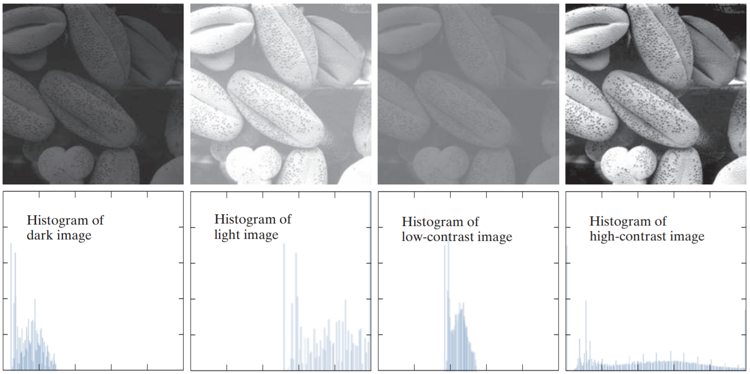

Figure 1 From left to right: Histogram corresponding to a (1) Dark image (2) Light image (3) Low-contrast image (4) High-contrast image

* Order-statistics filters for impulse noise - Median filters

Order-statistics filters define the new value of a pixel based on not just the value of the pixel itself but also considering the values of neighbor pixels. The most used order-statistics filter is the median filter, that defines an MxM filter where N is usually an odd number, where the new value of the pixel is replaced by the median value of the intensity values in its neighborhood. These filters are particularly effective against salt-and-pepper noise where black and black dots appear on an image.

An improvement to this algorithm is the implementation of adaptive median filters, where the median value is first diagnosed to check whether it is a product of noise itself or a non-noisy pixel that is fit to replace other pixels in the kernel of the convolution operation.

* Sharpening spatial filters - Laplacian filter

The intuition behind sharpening spatial filters is to highlight transitions in intensity values. This approach consists of first defining a kernel that can be applied using convolution with the original image to result in a sharpened output. The Laplacian has been shown to be the best operator for this method, being defined as:

$$∇^{2}f= \frac{∂^{2}f}{∂x^{2}}+ \frac{∂^{2}f}{∂y^{2}}$$

Using the definition of a second derivative:

$$\frac{∂^{2}f}{∂x^{2}}=f\left(x+1\right)+f\left(x-1\right)-2f(x)$$

It can be proven that a convolution kernel in the form of Figure 2(a) can be used to represent the formula. However, it can also include diagonal values into consideration as shown in Figure 2(b), adjusting the center value to be double by taking into consideration the extra pair of $-2f(x)$ each diagonal derivative would add to the kernel.

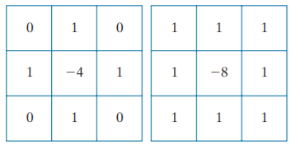

Figure 2 Laplacian kernels. (a) 4-neighbor kernel (b) 8-neighbor kernel

The result of the convolution operation would a representation of the edges that need to be intensified in the original image, thus, to obtain a result, we need to do the following operation:

$$g\left(x,y\right)=f\left(x,y\right)-∇^{2}f$$

Where $g\left(x,y\right)$ and $f\left(x,y\right)$ are the input and sharpened images, respectively.

* Power-law transformations

Power-law transformations, also called Gamma corrections, have the form:

$s=cr^{γ}$

Usually, it is assumed that $c=1$ and $r$ and $s$ are rescaled to be within $\left[0,1\right]$. The result of such transformations is shown in Figure 3 for different values of $γ$. Essentially, the output image for values of $γ<1$ has its darker pixels mapped to brighter values while leaving already bright pixels like their original values. For values of $γ>1$ the effect is the opposite, where bright pixels are mapped to darker values. For the case of $γ=1$, the equation reduces to an identity equation, leaving the image untouched.

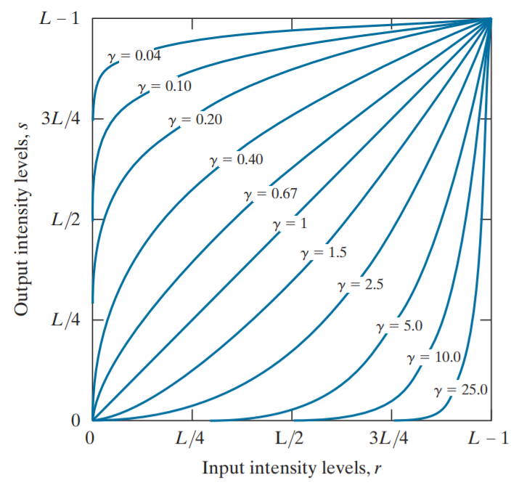

Figure 3 Gamma transformations for different $γ$ values

* Gaussian smoothing filter

The Gaussian smoothing filter is a 2-D convolutional filter which purpose is to blur the original image to remove details and noise. The resulting value of each pixel will be defined by a weighted sum of pixels in its neighborhood. The resulting formula can be defined as:

$$g\left(x,y\right)= \sum_{i}{\sum_{j}{\frac{1}{2πσ^{2}}e^{-\frac{x_{i}^{2}+ y_{j}^{2}}{2σ^{2}}}}}$$

In theory, the Gaussian function is non-zero for every pixel, but in practice, a kernel three times the size of $σ$ is sufficient, due to the small value of the function. The effects of the Gaussian smoothing filter are defined by the standard deviation of the function.

**Explanation of the experiments done**

* Histogram equalization

This method was applied to two different images with contrast problems, the first one is a color image and the second one is a black and white image. The color image is enhanced by modifying the values in its intensity channel, while pixels values are directly modified in the black and white image. The original and equalized histograms for the first image can be observed in the Figure 4. A comparation between the original and improved image can be seen in the Figure 5.

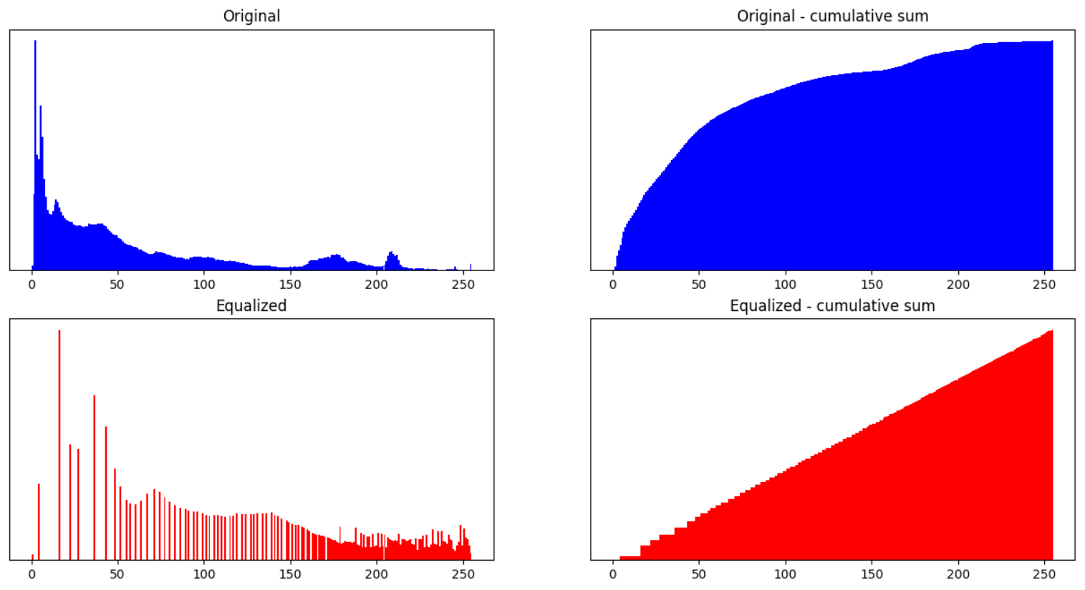

Figure 4 Top row: original image's intensity histogram and cumulative sum. Bottom row: Enhanced intensity histogram and cumulative sum.

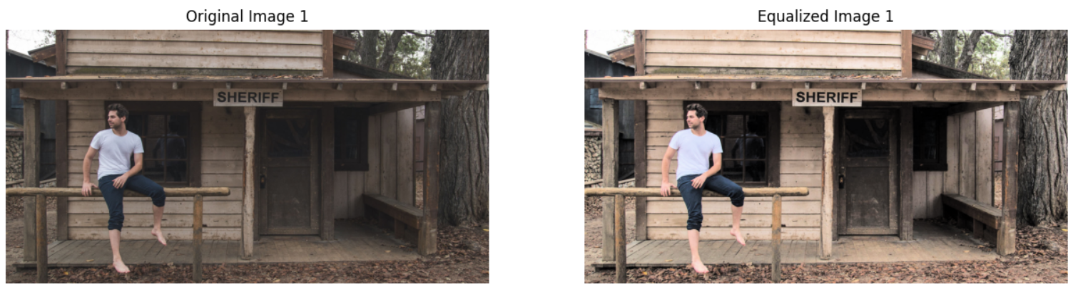

Figure 5 Intensity histogram equalization for a color image

The second image enhancement can be seen in the Figure 6.

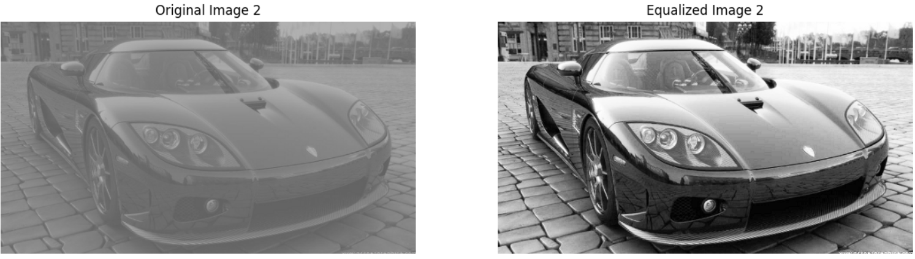

Figure 6 Intensity histogram equalization for a black and white image

* Median filters

To evaluate the effectiveness of the median filters an image that had impulse noise was selected. The median filters show excellent results in deleting impulse noise, as seen in Figure 7. In Figure 7(b) we can see the result of applying a 3x3 median filter on the image, the result was improved in Figure 7(c), where an adaptive median 3x3 filter was applied, helping the image to retain more detail where noise was lower. As a result of the median filter, there is a loss of detail around the edges of the objects, to counter this loss, a Laplace sharpening filter was applied to the image to obtain Figure 7(d).

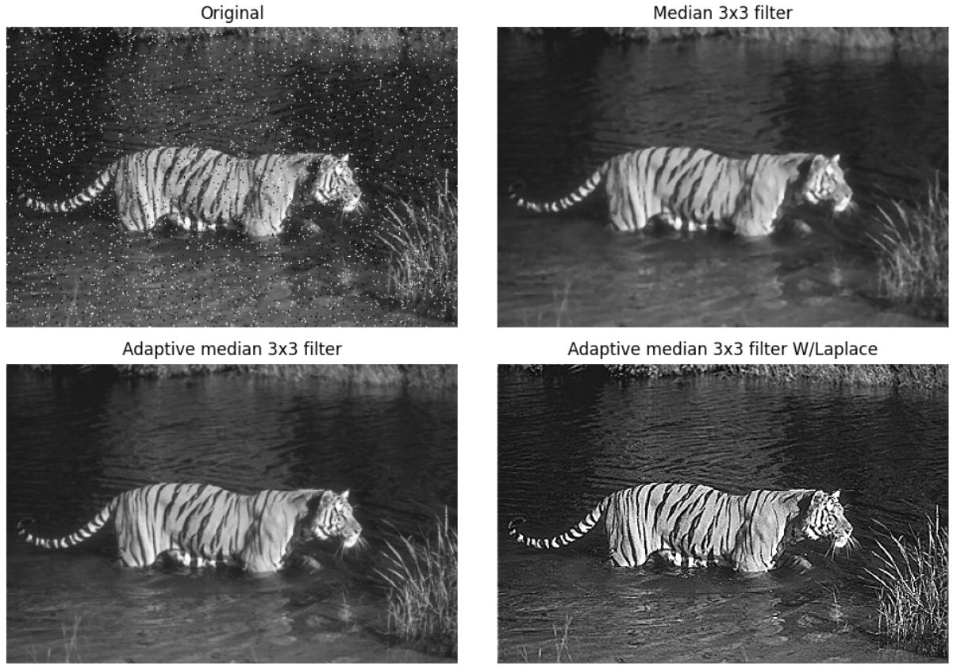

Figure 7 Median filter results on a noisy image. (a) Original image (b) Result of a 3x3 median filter (c) Result of a 3x3 filter with an adaptive median method (d) Result of applying sharpening to an adaptive 3x3 median filter

Following an algorithm proposed by Arumugam Rajamani et. Al, it was possible to improve an image containing impulse noise on its three-color channels with little distortion. This method also uses a median filter to eliminate noise and treats each channel independently. The original and denoised image can be seen in Figure 8. For these experiments, a lot of images were enhanced, but some presented too much noise to be effectively enhanced, the presented result is the best application of the algorithm.

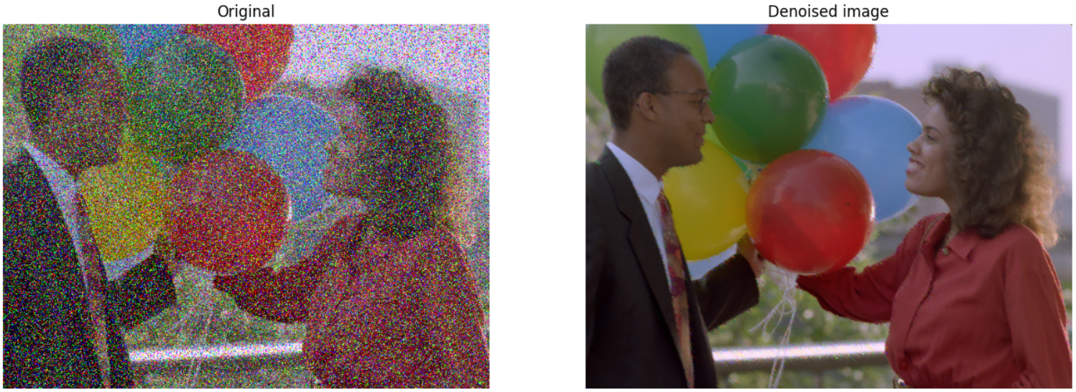

Figure 8 Color image with salt and pepper noise

* Laplacian filter

A sharpening Laplacian filter was applied on a to enhance a coins’ image as seen on Figure 9. Two different configurations of the Laplacian filter were used, the first had the form of Figure 2(a) and the second one was configured using the Figure 2 (b) model. In this case, because the photo was very blurry, the result of including diagonal information in the filter yielded a better result, as seen on the Figure 9(d), with a more defined mask in Figure 9(e).

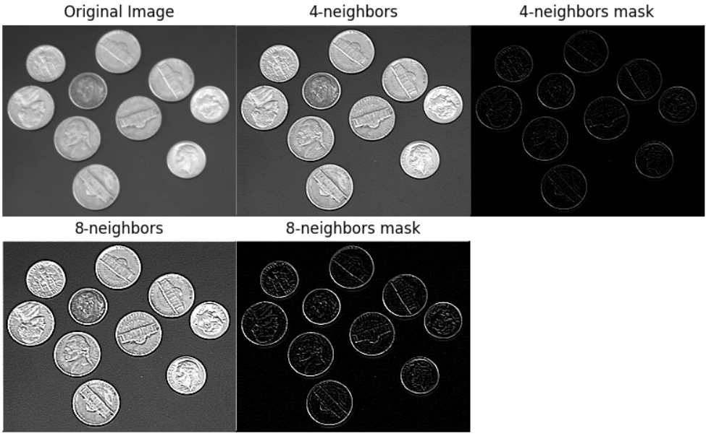

Figure 9 Top row from left to right: (a) Original image. (b) Sharpened output using a 4-neighbors Laplacian filter. (c) Mask from the 4-neighbors filter. Bottom row: (d) Sharpened image using an 8-neighbors Laplacian filter. (e) Mask from the 8-neighbors filter.

* Gamma corrections

The Gamma transformation method was implemented to handle color images in the HSV or RGB color model. For HSV images, the transformation is applied to the intensity channel, whereas for RGB images, the transformation is applied to only a single-color channel. In the example shown in Figure 10(b), gamma correction with $γ=0.7$ was applied on the red channel to balance the intensity of every channel. In Figure 10(c), a histogram equalization was applied on the previous result to further enhance the image.

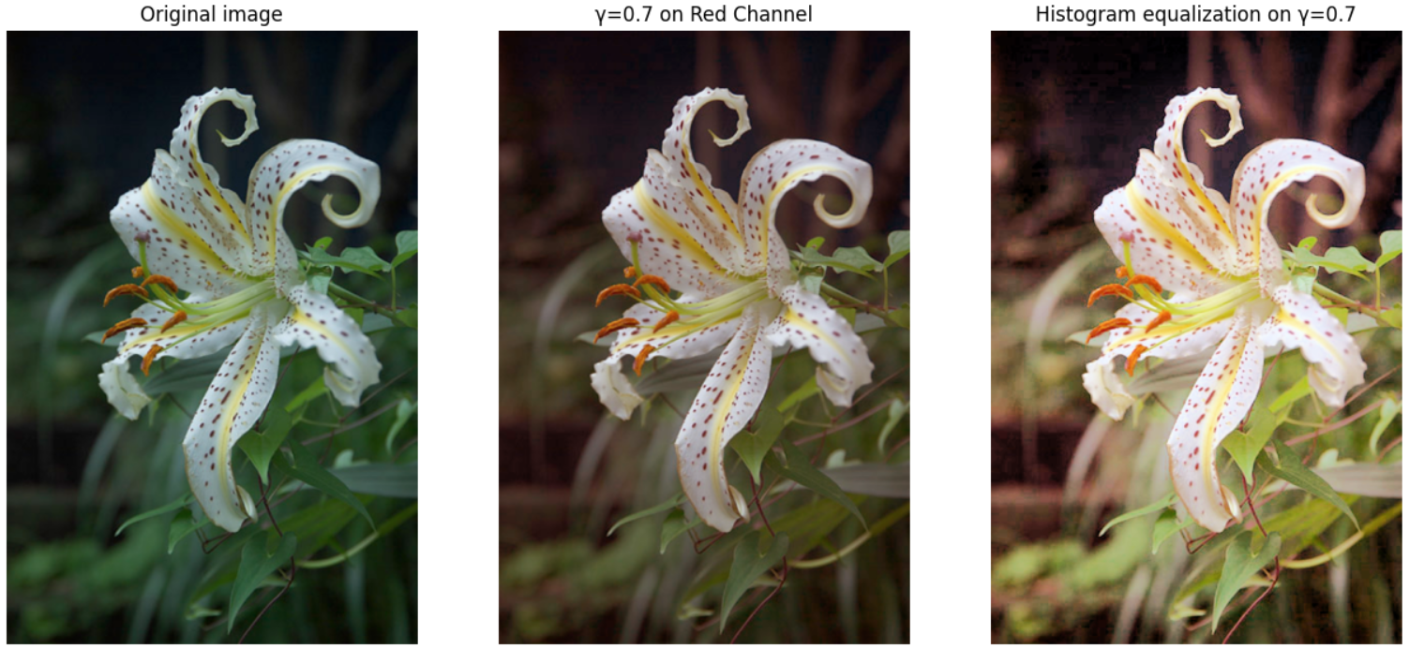

Figure 10 From left to right. (a) Original image (b) Gamma correction on red channel. (c) Gamma correction on red channel and histogram equalization

In Figure 11 we can see the effects of applying gamma correction with $γ=0.5$ on the intensity channel of an HSV-represented image. It can be noted that already well-lit parts, such as the forehead, are not over-exposed, while unseen details of the cheek are highlighted in the enhanced image. For this image different values of $γ$ were used.

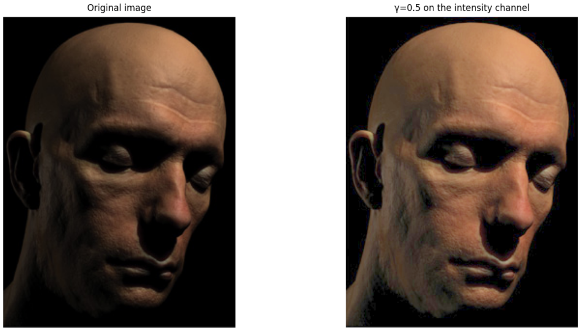

Figure 11 Gamma correction on the intensity channel of an HSV image

* Gaussian smoothing filter

The Gaussian smoothing filter helps remove noise from an image by blurring it, an image with heavy noise was tested for this method. The enhanced image can be seen in Figure 12, where a 7x7 Gaussian smoothing filter was used. The result can be seen as less noisy, but the cost is the sharpness of the details. For this experiment, different filter sizes and intensities were applied.

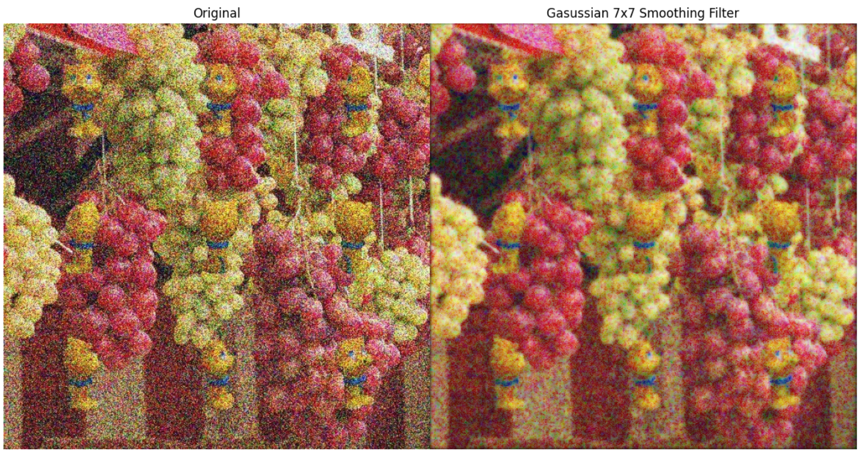

Figure Gaussian smoothing filter

**Discussions**

The results obtained for all the experiments satisfactorily enhance digital images, each method in a different way. However, it is important to be aware of the limitations of each method, as it is usually a good idea to combine different techniques on one single image to obtain a good resulting output. Despite one algorithm not being enough to enhance an image to its fullest, it is good to know that these algorithms keep improving over time, just like every technique out there, to further enhance images; for example, the very popular histogram equalization method now has more complex implementations that deliver better results, namely the AHE and CLAHE.

One disadvantage of most of the methods implemented in this work is that they have parameters that need to be adjusted and change depending on the initial image, so one set of parameters will not work for every image even if the underlying algorithm is the same. Moreover, there are some images that cannot be recovered due to the severe noise or degradation they present.

It should be noted that for these experiments, there were a lot of color model conversions, modifying an image’s representation from RGB to HSV color models and the other way around. These conversions make some enhancements possible and simpler, where modifying an image’s intensity channel is more convenient than individually modifying each color channel independently.

In summary, all the techniques implemented become part of a toolbox, where they need can be used to enhance an image, by combining and tuning them to fit the specific task at hand.

**Code**

import matplotlib.pyplot as plt  
import numpy as np  
import math  
import cv2  
import os  
  
########### Methods for image enhancement ###########  
*def* calculate_histogram(array, number_of_bins):  
 """Takes an array and a number of bins and returns the Probability Density Function of the histogram"""  
 min_val = np.amin(array)  
 max_val = np.amax(array)  
 interval = (max_val - min_val) / number_of_bins  
 bins = np.linspace(min_val, max_val, number_of_bins + 1)  
 frequencies = np.zeros(number_of_bins)  
 correspoding_bins = np.digitize(array, bins)  
  
 # Increments the corresponding bin's value by one  
 for resulting_bin in correspoding_bins:  
 if resulting_bin == number_of_bins + 1:  
 frequencies[-1] += 1  
 else:  
 frequencies[resulting_bin - 1] += 1   
  
 pdf = frequencies/interval/frequencies.sum() # Probability Density Function  
  
 return pdf, bins  
  
  
*def* cumulative_sum(array):  
 """Calculates the cumulative sum of the array"""  
 cumsum = np.zeros(array.shape)  
 cumsum[0] = array[0]  
 for i in *range*(1, array.shape[0]):  
 cumsum[i] = array[i] + cumsum[i - 1]  
 return cumsum  
  
  
*def* histogram_eq(image):  
 """ Take an Numpy HSV image array and performs histogram equalization.  
 The image is converted to HSV to change the Value channel but already returned as RGB for easy display  
 """  
 image_array = np.copy(image)  
 total_width, total_height, *_* = image_array.shape  
 X_STEP = 10  
 Y_STEP = 10  
   
 intensity_channel = image_array[:,:,2]  
 histogram, bins = calculate_histogram(intensity_channel.flatten(), 256)  
  
 original_hist = intensity_channel.flatten()  
  
 new_values = cumulative_sum(histogram) # cumulative distribution function   
 new_values = new_values / new_values[-1] # normalize all new values to be from [0,1]  
  
 # convert old values into the new equalized values  
 intensity_equalized = np.interp(intensity_channel.flatten(), bins[:-1], 255 * new_values)  
  
 # Update the image's value channel with the equalized one  
 image_array[:,:,2] = intensity_equalized.reshape(intensity_channel.shape)  
  
  
 equalized_hist = intensity_channel.flatten()  
 return cv2.cvtColor(image_array, cv2.COLOR_HSV2RGB), original_hist, equalized_hist  
  
*def* is_pixel_corrupted(pixel):  
 """Function that determines if a pixel is corrupted or not"""  
 return pixel == 0 or pixel == 255   
  
*def* salt_pepper_denoise(image, color = *False*, adaptive = *False*, filter_size=3):  
 """Remove salt & pepper noise by using a median filter."""  
 image_array = np.array(image)  
 if color:  
 # Implementation algorithm by Arumugam Rajamani et. Al  
 image_array = np.pad(image_array, pad_width=((1,1),(1,1),(0,0)), mode='constant')  
 X_STEP = filter_size  
 Y_STEP = filter_size  
 for channel in *range*(3): # For all three colors  
 for Xo in *range*(image_array.shape[0] - 2):  
 for Yo in *range*(image_array.shape[1] - 2):  
 Xf = Xo + X_STEP  
 Yf = Yo + Y_STEP  
 region = image_array[Xo:Xf,Yo:Yf,channel] # Window region  
 sorted_diag = np.sort(np.array([region[0,0],region[1,1],region[2,2]])) # Sorted diagonal values  
 clear_pixels = np.array([(sorted_diag>0) & (sorted_diag<255)]).reshape(3) # Values that don't have noise  
   
 # If none of the pixels have noise, there's nothing to do, continue with the next window  
 if np.all(clear_pixels):  
 continue  
  
 # Choose a healthy pixel from the sorted pixels, starting from the median  
 replacement = *None*  
 if clear_pixels[1]:  
 replacement = sorted_diag[1]  
 elif clear_pixels[0]:  
 replacement = sorted_diag[0]  
 elif clear_pixels[2]:  
 replacement = sorted_diag[2]  
   
 # If all three pixels from the diagonal are corrupted, just replace the the upper-left pixel  
 # from the window with a non-noisy 4-neighborhood pixel.  
 if replacement is *None* and is_pixel_corrupted(image_array[Xo,Yo,channel]):  
 if (not is_pixel_corrupted(image_array[Xo+1,Yo, channel])):  
 image_array[Xo,Yo,channel] = image_array[Xo+1, Yo, channel]  
 elif (Xo > 0 and not is_pixel_corrupted(image_array[Xo-1,Yo,channel])):  
 image_array[Xo,Yo,channel] = image_array[Xo-1, Yo, channel]  
 elif (Yo > 0 and not is_pixel_corrupted(image_array[Xo,Yo-1,channel])):  
 image_array[Xo,Yo,channel] = image_array[Xo, Yo-1, channel]  
 else:  
 image_array[Xo,Yo,channel] = image_array[Xo, Yo+1, channel]  
 elif replacement is not *None*:  
 # If there is a non-noisy pixel in the diagonal, replace other noisy values with this one  
 for i in *range*(3):  
 if is_pixel_corrupted(region[i,i]):  
 image_array[Xo+i,Yo+i,channel] = replacement  
  
 return image_array  
 else:  
 # For B&W images  
 image_array = cv2.cvtColor(image_array, cv2.COLOR_BGR2GRAY)  
 resulting_array = np.copy(image_array)  
 if adaptive:  
 # Use an Adaptive Median Filter  
 image_array = np.pad(image_array, 1, mode='constant')  
 height, width = resulting_array.shape  
  
 for Xo in *range*(height):  
 for Yo in *range*(width):  
 filter_size = 3  
 while *True*:  
 X_STEP = filter_size  
 Y_STEP = filter_size  
 Xf = Xo + X_STEP  
 Yf = Yo + Y_STEP  
 region = image_array[Xo:Xf,Yo:Yf] # Window size  
 Zxy = resulting_array[Xo, Yo]  
 Zmed = np.median(region)  
 if Zmed == 0 or Zmed == 255:  
 # If the Zmed is an extreme value, increase window and continue the cycle or leave the original Zxy  
 if Xo-1 > 0 and Yo-1 > 0 and Xf+1 < resulting_array.shape[0] and Yf+1 < resulting_array.shape[1]:  
 filter_size += 2  
 else:  
 # Leave the original value  
 break  
 else:  
 if Zxy == 0 or Zxy == 255:  
 # If the Zmed is not corrupted and Zxy is corrupted replace the value  
 resulting_array[Xo, Yo] = Zmed  
 break  
 else:  
 # Is Zxy is not corrupted leave it  
 break   
 else:  
 image_array = np.pad(image_array, 1, mode='constant')  
 X_STEP = filter_size  
 Y_STEP = filter_size  
 height, width = resulting_array.shape  
 for Xo in *range*(height):  
 for Yo in *range*(width):  
 Xf = Xo + X_STEP  
 Yf = Yo + Y_STEP  
 region = image_array[Xo:Xf,Yo:Yf]  
  
 # Replace the value with the median of the filter  
 resulting_array[Xo, Yo] = np.median(region)  
  
 return resulting_array  
  
*def* laplacian(image, filter_config, filter_size = 3, color = *False*):  
 if color:  
 # Process BGR image  
 image_array = np.array(image)  
 sharpened_image = np.copy(image_array)  
 image_array = np.pad(image_array, pad_width=((1,1),(1,1),(0,0)), mode='constant')  
 resulting_mask = np.zeros(sharpened_image.shape)  
 for channel in *range*(2): # For all three color channels  
 resulting_channel = np.zeros((image_array.shape[0]-2,image_array.shape[1]-2))  
 X_STEP = filter_size  
 Y_STEP = filter_size  
 height, width = resulting_channel.shape  
  
 # The filter config contains the matrix definition for the filter  
 laplacian_filter = -1 * np.array(filter_config).reshape((filter_size,filter_size))  
 for Xo in *range*(height):  
 for Yo in *range*(width):  
 Xf = Xo + X_STEP  
 Yf = Yo + Y_STEP  
 if Yf > width:  
 continue  
 if Xf > height:  
 continue  
 region = image_array[Xo:Xf,Yo:Yf,2]  
   
 # Apply the filter  
 resulting_channel[Xo,Yo] = np.sum(np.multiply(region, laplacian_filter))  
  
 sharpened_image[:,:,channel] = image_array[1:-1,1:-1,channel] + resulting_channel  
 sharpened_image[:,:,channel] = sharpened_image[:,:,channel] / np.max(sharpened_image[:,:,channel]) * 255  
 resulting_mask[:,:,channel] = resulting_channel  
 # Return the sharpenend image and the laplacian mask used  
 return cv2.cvtColor(sharpened_image.astype('uint8'), cv2.COLOR_BGR2RGB), cv2.cvtColor(resulting_mask.astype('uint8'), cv2.COLOR_BGR2RGB)  
 else:  
 image_array = np.array(image)  
 image_array = cv2.cvtColor(image_array, cv2.COLOR_BGR2GRAY)  
 resulting_array = np.zeros(image_array.shape)  
 image_array = np.pad(image_array, 1, mode='constant')  
 X_STEP = filter_size  
 Y_STEP = filter_size  
 height, width = resulting_array.shape  
  
 # The filter config contains the matrix definition for the filter  
 laplacian_filter = -1 * np.array(filter_config).reshape((filter_size,filter_size))  
 for Xo in *range*(height):  
 for Yo in *range*(width):  
 Xf = Xo + X_STEP  
 Yf = Yo + Y_STEP  
 if Yf > width:  
 continue  
 if Xf > height:  
 continue  
 region = image_array[Xo:Xf,Yo:Yf]  
   
 # Apply the filter  
 resulting_array[Xo,Yo] = np.sum(np.multiply(region, laplacian_filter))  
  
 sharpened_image = (image_array[1:-1,1:-1] + resulting_array)  
  
 # Return the sharpenend image and the laplacian mask used  
 return sharpened_image, resulting_array  
  
*def* check_gamma_values(image):  
 """ Shows an histogram of the three color channels of an image,   
 to help decide if gamma correction would work or not.  
 """   
 plt.style.use('seaborn-deep')  
 plt.hist([image[:,:,0].flatten(),image[:,:,1].flatten(),image[:,:,2].flatten()],   
 bins=256, range=(0, 255), alpha=0.5, label=['red','green','blue'], color=['red','green','blue'])  
 plt.legend(loc='upper right')  
 plt.show()  
  
*def* gamma_correction(image, gamma=1, c=1, channel=2):  
 """ Takes an image and applies gamma correction to it. Can be applied to the value channel on  
 an HSV image or on a single color channel on an RGB image.  
 """   
 image_array = np.array(image)  
 channel_to_modify = image_array[:,:,channel] / 255  
  
 # do gamma correction on value channel  
 val_gamma = c * channel_to_modify ** gamma  
 image_array[:,:,channel] = val_gamma * 255  
  
 return image_array  
  
   
*def* get_kernel(size, sigma):  
 """ Get the filter with the Gaussian formula applied to its original values. """   
  
 # Creating a vector of the desired size and evenly spaced  
 kernel = np.linspace(-(size // 2), size // 2, size)  
  
 # Calculate the gaussian for each vector element  
 for i in *range*(size):  
 kernel[i] = 1 / (np.sqrt(2 * np.pi) * sigma) * np.e ** (-np.power((kernel[i]) / sigma, 2) / 2)  
  
 # Transform the vector into a matrix, to use in in the convolution process  
 kernel = np.outer(kernel.T, kernel.T)  
  
 # Normalizing the kernel  
 kernel *= 1.0 / kernel.max()  
 return kernel  
  
  
*def* gaussian_blur(image, filter_size, color):  
 """ Perform Gaussian Blur on an image. """   
 kernel = get_kernel(filter_size, math.sqrt(filter_size))  
 image_array = np.array(cv2.cvtColor(image, cv2.COLOR_BGR2HSV))  
 if color:  
 # For color images, perform the process on the value channel of an HSV image  
 height, width, *_* = image_array.shape  
 X_STEP, Y_STEP = kernel.shape  
  
 resulting_array = np.zeros(image_array.shape)  
 resulting_array[:,:,0] = image_array[:,:,0]  
 resulting_array[:,:,1] = image_array[:,:,1]  
 pad_height = *int*((X_STEP - 1) / 2)  
 pad_width = *int*((Y_STEP - 1) / 2)  
  
 padded_image = np.zeros((height + (2 * pad_height), width + (2 * pad_width)))  
 padded_image[pad_height:padded_image.shape[0] - pad_height, pad_width:padded_image.shape[1] - pad_width] = image_array[:,:,2]  
  
 # Perfom the convolutions  
 for Xo in *range*(height):  
 for Yo in *range*(width):  
 Xf = Xo + X_STEP  
 Yf = Yo + Y_STEP  
 resulting_array[Xo, Yo, 2] = np.sum(kernel * padded_image[Xo:Xf, Yo:Yf])  
 resulting_array[:,:,2] = resulting_array[:,:,2] * 255 / np.max(resulting_array[:,:,2])  
  
 return resulting_array   
 else:  
 # For B&W images  
 if *len*(image_array.shape) == 3:  
 image_array = cv2.cvtColor(image_array, cv2.COLOR_BGR2GRAY)  
   
 height, width = image_array.shape  
 X_STEP, Y_STEP = kernel.shape  
  
 resulting_array = np.zeros(image_array.shape)  
  
 pad_height = *int*((X_STEP - 1) / 2)  
 pad_width = *int*((Y_STEP - 1) / 2)  
  
 padded_image = np.zeros((height + (2 * pad_height), width + (2 * pad_width)))  
 padded_image[pad_height:padded_image.shape[0] - pad_height, pad_width:padded_image.shape[1] - pad_width] = image_array  
  
 # Perfom the convolutions  
 for Xo in *range*(height):  
 for Yo in *range*(width):  
 Xf = Xo + X_STEP  
 Yf = Yo + Y_STEP  
 resulting_array[Xo, Yo] = np.sum(kernel * padded_image[Xo:Xf, Yo:Yf])  
 return resulting_array  
  
  
  
########### Image Enhancement Results ###########  
gaussian_blur_color = *False*  
if gaussian_blur_color:  
  
 image_original = cv2.imread(os.path.join(os.path.dirname(__file__), "fruits.png")).astype('uint8')  
 # image_gaussian = gaussian_blur(image_original, 5, True)  
 image_gaussian2 = gaussian_blur(image_original, 7, *True*)  
  
 fig = plt.figure(figsize=(15,15))  
 rows = 1  
 columns = 2  
  
 fig.add_subplot(rows, columns, 1)  
 plt.imshow(cv2.cvtColor(image_original, cv2.COLOR_BGR2RGB))  
 plt.axis('off')  
 plt.title("Original")  
  
 # fig.add_subplot(rows, columns, 2)  
 # plt.imshow(cv2.cvtColor(image_gaussian.astype('uint8'), cv2.COLOR_HSV2RGB), vmin=0, vmax=255)  
 # plt.axis('off')  
 # plt.title("Gaussian 5x5")  
  
 fig.add_subplot(rows, columns, 2)  
 plt.imshow(cv2.cvtColor(image_gaussian2.astype('uint8'), cv2.COLOR_HSV2RGB), vmin=0, vmax=255)  
 plt.axis('off')  
 plt.title("Gasussian 7x7 Smoothing Filter")  
  
 plt.subplots_adjust(wspace=0, hspace=0)  
 plt.show()  
  
  
laplacian_tests = *False*  
if laplacian_tests:  
 image_parrots = cv2.imread(os.path.join(os.path.dirname(__file__), "coins.png"))  
 filter4_4neighbors, filter4_4neighbors_mask = laplacian(image_parrots,[0,1,0,1,-4,1,0,1,0], color = *False*)  
 filter8_all, filter8_all_mask = laplacian(image_parrots,[1,1,1,1,-8,1,1,1,1], color = *False*)  
 fig = plt.figure(figsize=(10, 7))  
 # setting values to rows and column variables  
 rows = 2  
 columns = 3  
  
 fig.add_subplot(rows, columns, 1)  
 plt.imshow(cv2.cvtColor(image_parrots, cv2.COLOR_BGR2GRAY), cmap='gray', vmin=0, vmax=255)  
 plt.axis('off')  
 plt.title("Original Image")  
  
 fig.add_subplot(rows, columns, 2)  
 plt.imshow(filter4_4neighbors, cmap='gray', vmin=0, vmax=255)  
 plt.axis('off')  
 plt.title("4-neighbors")  
  
   
 fig.add_subplot(rows, columns, 3)  
 plt.imshow(filter4_4neighbors_mask, cmap='gray', vmin=0, vmax=255)  
 plt.axis('off')  
 plt.title("4-neighbors mask")  
  
 fig.add_subplot(rows, columns, 4)  
 plt.imshow(filter8_all, cmap='gray', vmin=0, vmax=255)  
 plt.axis('off')  
 plt.title("8-neighbors")  
  
   
 fig.add_subplot(rows, columns, 5)  
 plt.imshow(filter8_all_mask, cmap='gray', vmin=0, vmax=255)  
 plt.axis('off')  
 plt.title("8-neighbors mask")  
  
 plt.subplots_adjust(wspace=0, hspace=-0.2)  
 plt.show()  
  
  
doSaltPepperColor = *False*  
if doSaltPepperColor:  
 image_parrots = cv2.imread(os.path.join(os.path.dirname(__file__), "balloons_noisy.png"))  
 image_parrots = cv2.cvtColor(image_parrots, cv2.COLOR_BGR2RGB)  
 image_parrots_denoise_color = salt_pepper_denoise(image_parrots, color=*True*, adaptive=*False*)  
   
 fig = plt.figure()  
 rows = 1  
 columns = 2  
  
 fig.add_subplot(rows, columns, 1)   
 plt.imshow(image_parrots)  
 plt.axis('off')  
 plt.title("Original")  
  
 fig.add_subplot(rows, columns, 2)   
 plt.imshow(image_parrots_denoise_color)  
 plt.axis('off')  
 plt.title("Denoised image")  
  
 plt.show()  
  
  
doSaltPepper = *False*  
if doSaltPepper:  
  
 image_1 = cv2.imread(os.path.join(os.path.dirname(__file__), "tigernoise.png"))  
 image_1_denoise = salt_pepper_denoise(image_1, color=*False*, adaptive=*False*)  
 image_1_denoise_adapt = salt_pepper_denoise(image_1, color=*False*, adaptive=*True*)  
 image_1_denoise_adapt_laplace, mask = laplacian(cv2.cvtColor(image_1_denoise_adapt, cv2.COLOR_GRAY2BGR),[0,1,0,1,-4,1,0,1,0], color = *False*)  
  
 fig = plt.figure()  
 rows = 2  
 columns = 2  
  
 fig.add_subplot(rows, columns, 1)  
 plt.imshow(image_1, cmap = 'gray', vmin=0, vmax=255)  
 plt.axis('off')  
 plt.title("Original")  
  
 fig.add_subplot(rows, columns, 2)  
 plt.imshow(image_1_denoise, cmap = 'gray', vmin=0, vmax=255)  
 plt.axis('off')  
 plt.title("Median 3x3 filter")  
  
 fig.add_subplot(rows, columns, 3)  
 plt.imshow(image_1_denoise_adapt, cmap = 'gray', vmin=0, vmax=255)  
 plt.axis('off')  
 plt.title("Adaptive median 3x3 filter")  
  
 fig.add_subplot(rows, columns, 4)  
 plt.imshow(image_1_denoise_adapt_laplace, cmap = 'gray', vmin=0, vmax=255)  
 plt.axis('off')  
 plt.title("Adaptive median 3x3 filter W/Laplace")  
  
 plt.show()  
  
gamma_correction_tests = *False*  
if gamma_correction_tests:  
 image = cv2.imread(os.path.join(os.path.dirname(__file__), "cara.png"))  
 image_gamma_corrected = gamma_correction(cv2.cvtColor(image, cv2.COLOR_BGR2HSV), gamma=0.5, channel=2)  
 # image_gamma_corrected_eq = histogram_eq(cv2.cvtColor(image_gamma_corrected.astype('uint8'), cv2.COLOR_RGB2HSV))[0]  
  
  
 fig = plt.figure()  
 rows = 1  
 columns = 2  
  
 fig.add_subplot(rows, columns, 1)  
 plt.imshow(cv2.cvtColor(image, cv2.COLOR_BGR2RGB))  
 plt.axis('off')  
 plt.title("Original image")  
  
 fig.add_subplot(rows, columns, 2)  
 plt.imshow(cv2.cvtColor(image_gamma_corrected, cv2.COLOR_HSV2RGB))  
 plt.axis('off')  
 plt.title("γ=0.5 on the intensity channel")  
  
 plt.show()  
  
  
histogram_eq_tests = *False*  
if histogram_eq_tests:  
 image_1 = cv2.imread(os.path.join(os.path.dirname(__file__), "mujer2.jpg"))  
 image_1_eq, img_1_hist, img_1_normalized = histogram_eq(cv2.cvtColor(image_1.astype('uint8'), cv2.COLOR_BGR2HSV))  
 image_2 = cv2.imread(os.path.join(os.path.dirname(__file__), "carro.png"))  
 image_2_eq, img_2_hist, img_2_normalized = histogram_eq(cv2.cvtColor(image_2.astype('uint8'), cv2.COLOR_BGR2HSV))  
   
 fig = plt.figure()  
 rows = 2  
 columns = 2  
   
 fig.add_subplot(rows, columns, 1).axes.get_yaxis().set_visible(*False*)  
 plt.hist(img_1_hist, bins=256, range=(0, 255), color='blue')  
 plt.title("Original")  
   
 fig.add_subplot(rows, columns, 2).axes.get_yaxis().set_visible(*False*)  
 plt.hist(img_1_hist, bins=256, range=(0, 255), color='blue', cumulative=*True*)  
 plt.title("Original - cumulative sum")  
   
   
 fig.add_subplot(rows, columns, 3).axes.get_yaxis().set_visible(*False*)  
 plt.hist(img_1_normalized, bins=256, range=(0, 255), color='red')  
 plt.title("Equalized")  
   
 fig.add_subplot(rows, columns, 4).axes.get_yaxis().set_visible(*False*)  
 plt.hist(img_1_normalized, bins=256, range=(0, 255), color='red', cumulative=*True*)  
 plt.title("Equalized - cumulative sum")  
   
 plt.show()  
  
 fig = plt.figure()  
 rows = 1  
 columns = 2  
  
 fig.add_subplot(rows, columns, 1)  
 plt.imshow(cv2.cvtColor(image_1.astype('uint8'), cv2.COLOR_BGR2RGB))  
 plt.axis('off')  
 plt.title("Original Image 1")  
  
 fig.add_subplot(rows, columns, 2)  
 plt.imshow(image_1_eq)  
 plt.axis('off')  
 plt.title("Equalized Image 1")  
  
 plt.show()  
  
 fig = plt.figure()  
 rows = 1  
 columns = 2  
  
 fig.add_subplot(rows, columns, 1)  
 plt.imshow(image_2, cmap = 'gray', vmin=0, vmax=255)  
 plt.axis('off')  
 plt.title("Original Image 2")  
  
 fig.add_subplot(rows, columns, 2)  
 plt.imshow(image_2_eq, cmap = 'gray', vmin=0, vmax=255)  
 plt.axis('off')  
 plt.title("Equalized Image 2")  
  
 plt.show()